43.28: a) Solving Eq. (43.19) for ,
b) 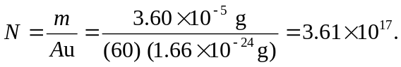
c) 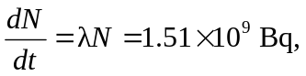which is d) 0.0408 Ci. The same calculation for radium, with larger and longer half-life (lower ) gives

